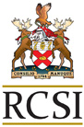
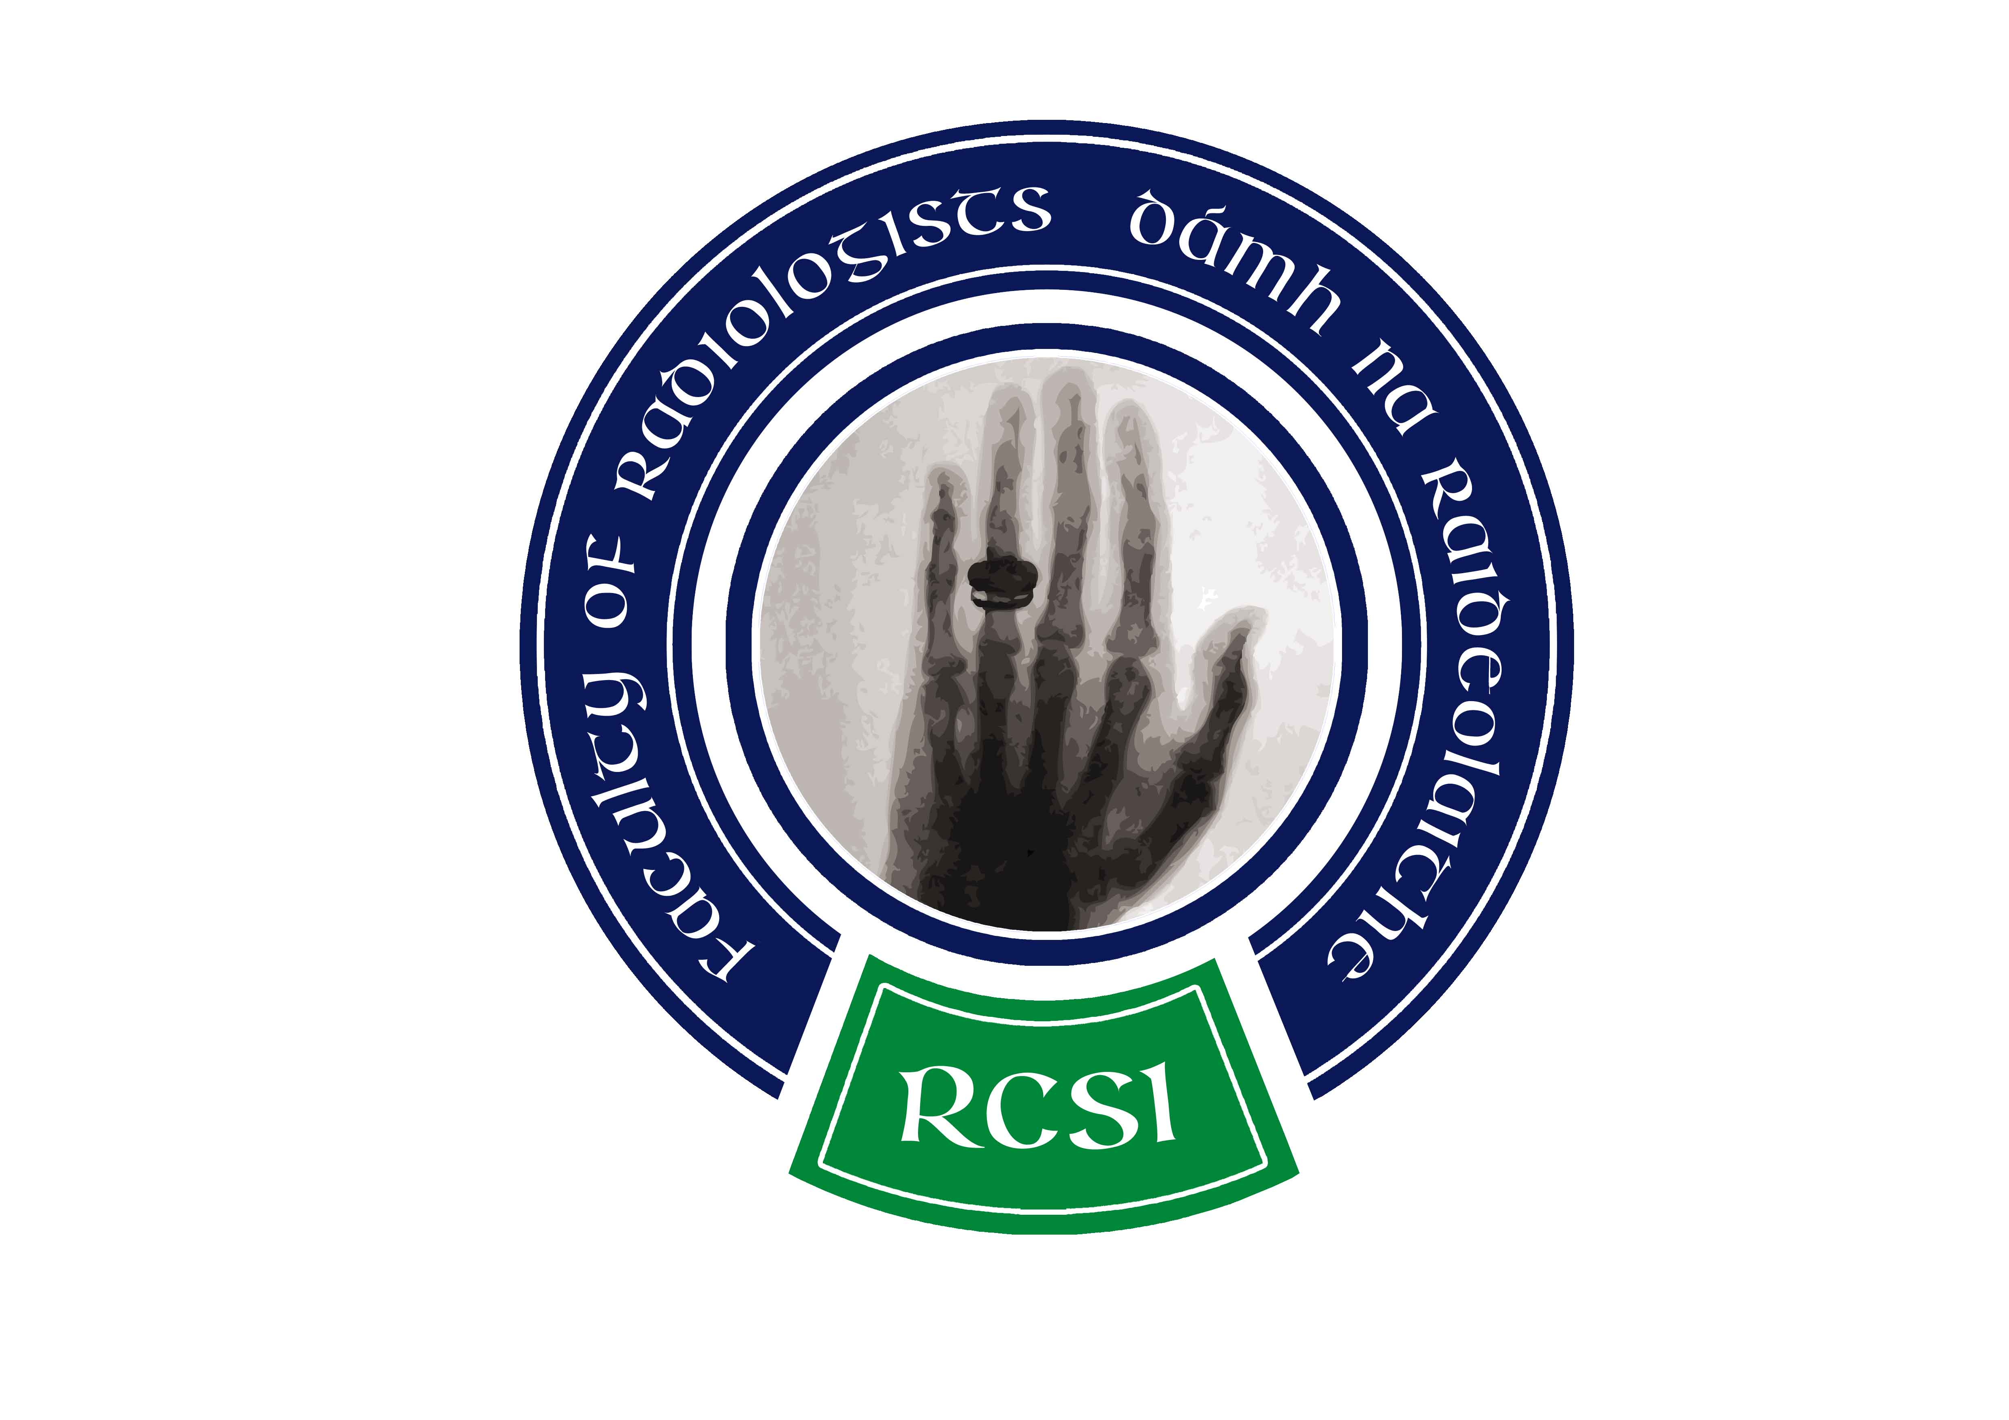
Faculty of Radiologists
Royal College of Surgeons in Ireland
123 St Stephen’s Green
Dublin 2

Approval of Events for PCS Accreditation
External Credits Category

Title of Event: |  | Date of Event:
Full Address of Venue:
Medical Organiser: |  | Event Administrator (if different):
Name |  | Name
Hospital/Institute |  | Hospital/Institute
Phone |  | Phone
Email |  | Email
Mobile |  | Mobile
Organising Committee |  | Address
What are the Target Medical Speciality(ies)?
What are the Specific Skills and Learning Objectives of the event?
Identify Domains of Professional Practice to be Covered:
□ Clinical Skills
□ Professionalism
□ Scholarship
□ Patient Safety and Quality of Patient Care
□ Relating to Patients
□ Communication & Interpersonal Skills
□ Collaboration & Teamwork
□ Management (Including Self-Management)
Please indicate the format of the meeting i.e. Lectures, tutorials etc.
Methods of Evaluation i.e. feedback form

Is sponsorship sourced from a commercial organisation?
Tick = Yes Blank = No
Event is not sponsored □ Single Sponsor organising event □
Multiple Sponsors □
Unrestricted Educational grant □
If the event is sponsored, please complete the following section

Sponsorship covers:  Prizes □ Speakers □  Breaks □  Meals □ | Main Sponsor:  Contact Name:
Additional Sponsors:
Sponsorship Declaration |  | Tick = Yes  Blank = No
The learning component of this event is unbiased |  | □
Display tables/material related to sponsor or sponsor’s products will not be placed in the education area (lecture theatre or room where educational content is delivered) |  | □
The sponsorship arrangements for this event are compliant with the guidelines of the Irish Pharmaceutical Healthcare Association |  | □
Checklist of items to accompany this application
A full programme of the event, indicating individual start and finish times of each activity |  | □
A written disclaimer by the organisers that none of the presentations / lectures involves direct trade promotional activity |  | □
Copy of feedback form available to delegates |  | □
Where applicable, application fee for Commercial Education Activities at the rate indicated below |  | □
A copy of the invitation |  | □
Speaker details/biographies |  | □
Details of any commercial or promotional aspect to the event or any sessions, or speakers’ connection to the drug company or medical device company |  | □
Reciprocity between training bodies
Postgraduate Medical Training bodies will recognise PCS credits issued by other training bodies.
Event providers are advised to apply to only one training body for credit. This application should be to the PGTB that is most relevant to the content of the event.
Fee for PCS Accreditation of Commercial Educational Activities
A fee structure of €250 applies to commercial organisations seeking PCS accreditation.

Submit this form and supporting documents to:
Sarah Drumm
Faculty of Radiologists
Royal College of Surgeons in Ireland
123 St Stephen’s Green
Dublin 2
Tel: 01-402 2139 | Fax: 01-402 2466
www.radiology.ie | pcs@radiology.ie

