

**Trainee in Difficulty:**

A trainee may come to your attention from a variety of sources. You may directly observe that your trainee is struggling with their workload. Additionally a concern may be expressed by a fellow consultant, trainee, or allied health staff. Alternatively, and less commonly, a trainee may come to you and identify themselves as experiencing difficulty.

Below are some signs and behaviours that may assist you in identifying a trainee in difficulty:

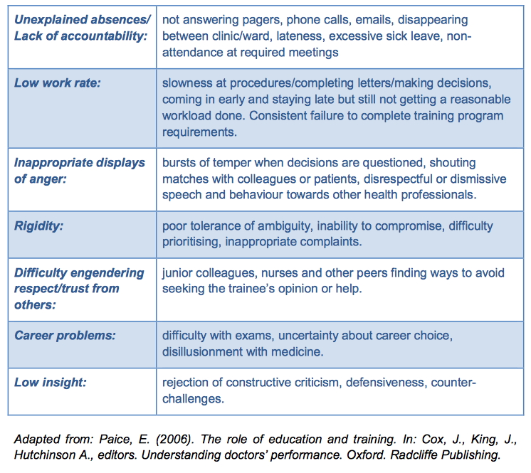

**Three Levels of Difficulty**

|  |  |  |
| --- | --- | --- |
| **Level 1** | **Level 2** | **Level 3** |
| **Minor Concerns** | **Serious Concerns** | **Concerns that threaten progression of training** |
|  |  |  |
| **Lead: Educational Coordinator** | **Lead: Educational Coordinator/ Dean/ Chair of Fellowship Advisory Committee** | **Lead: Dean /Full Fellowship Advisory Committee** |
|  |  |  |
| **Examples:** | **Examples:** | **Examples:** |
| **Exam Failure** | **Poor overall clinical knowledge and skills** | **Complex, longstanding issues** |
| **Poor knowledge/skills in a few areas** | **Persistent Problem** | **Issues include serious disciplinary or health problems** |
|  |  |  |
| **Difficulty demonstrating competencies** | **Difficulty learning from experience** |  |
|  | **Difficult relationships** | **Problems with progression of training(Failed or suspended assessment)** |

*Adapted from the Oxford Deanery Trainees in Difficulty training module.*

**Seven Point Plan:**

1. Investigate: Does the reported problem indicate a one-off problem or genuinely a trainee in difficulty? Consider seeking SpRs permission to review their multisource feedback reports (if they were in a cohort that underwent MSF in 3rd or 4th year).
2. Interview:

NB: meet the trainee at an early stage with clinical supervisor/consultant colleague and share reports/complaints.

*Remember if it’s not written down it didn’t happen.*

* *Tell the SpR about all negative feedback and document all meetings using a ‘Green Form’ which must be signed by the SpR and the Educational Coordinator.*
* *For problems considered serious and/ or shown to be recurrent patterns use the ‘Yellow Form’ to guide local planning with the SpR.*

1. Educational review report: primarily for the trainee. Records actions and plans.
2. Performance Improvement plan: Identify specific objective for each concern. Plan how to assess progress for each concern and define specific criteria for success.
3. Monitoring and review: To ensure progress is being made.
4. Referral to Fellowship Advisory Committee: Refer to FAC if there are concerns about patient safety or lack of progress despite reasonable intra-departmental attempts at remediation. Each referral must be accompanied by the ‘Green Forms’ and the ‘Yellow Form.’
5. If the SpR and Educational Coordinator resolve the problem locally: There is, in these cases, no need to refer the matter to the Faculty FAC. When the SpR has been awarded their CSCST certificate, the relevant Green/ Yellow forms may be destroyed. In the meantime, they *must* be kept in confidence by the Educational Coordinator as resolution of problems can sometimes be only temporary and they will be needed if problems recur/ are reported from a different hospital during rotations or in 5th year/ Fellowship abroad. Information about projected SpR CSCST dates can be obtained from Ms. Karen Milling in the Faculty of Radiologists.