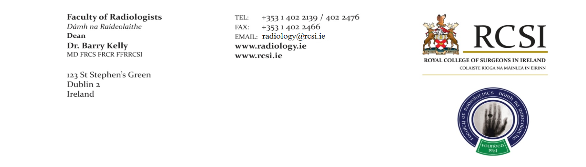**Professional Competence Scheme Application Form**

|  |
| --- |
| Title  Professor, Doctor, Mr, Ms, other |
| Forename |
| Middle Name(s) |
| Family name |
| Gender |
| Date of Birth |
| Place of Birth |
| Email Address |
| Home Telephone Number |
| Mobile Telephone Number |
| Specialty: Diagnostic Radiology  Radiation Oncology |
| Country of Qualification & Name of Training Body |
| Place of Work |
| Preferred Address: Work  Home  Other |
| Address |
|  |
|  |
|  |
|  |
| Irish Medical Council Number |
| Are you currently on the Irish Medical Council:  Division of Radiology Specialist Register  Specialist Training Division  General Register |
| Are you requesting enrolment to the Faculty of Radiologists Professional Competence Scheme for the first time? Yes/No |
| Have you been refused enrolment to the Faculty of Radiologists Professional Competence Scheme in the past year? Yes/No |
| **Subscription Details – please select the relevant options**   * Fellows of the Faculty of Radiologists (FFR RCSI)   + Examination Ad eundem   + Consultant Status Non-consultant Status   + Full-time Part-time*   + Overseas†   + Retired‡ * Members of the Faculty of Radiologists   + Consultant Status Non-consultant Status   + Full-time Part-time*   + Overseas†   + Retired‡ * Non-fellows/members   * This includes all those working ≤ 20 hours per week and those not working but wishing to avail of PCS. Supporting documentation may be requested upon application  † Please note that PCS registration with the Faculty is not required if practicing for less than 30 days per annum in Ireland, or participating in overseas CPD structures in line with Medical Council standards  ‡ Please note that PCS registration is required if you are on the Irish Medical Register |
| **Annual Subscriptions & PCS Fees**   1. **Fellows/Members of the Faculty of Radiologists in full-time practice in Ireland:** 2. **Consultant Status:**   Annual subscription (not including PCS registration): €350   1. **Non-Consultant Status:**   Annual subscription (not including PCS registration): €250   1. **Fellows/Members of the Faculty of Radiologists in part-time practice in Ireland:**   Annual subscription (not including PCS registration): €200   1. **Overseas Fellows/Members of the Faculty of Radiologists:**   Annual subscription (not including PCS registration): €250   1. **Retired Fellows/Members of the Faculty of Radiologists:**   Annual subscription (not including PCS registration): €50   1. **PCS Fees for Fellows/Members in good standing:**   €150   1. **PCS Fees for non-Fellows/Member:**   €250 annual fee plus €250 once-off charge for new registrants   1. **Associate Members**   Annual Subscription: €50 |

**Faculty Subscription & Professional Competence Fees Payment Form**

Payment by card  cheque enclosed

If paying by credit card, please complete the credit card details below and return to the

Faculty of Radiologists Office at the address below

I authorise deduction of **€________** from my:

Visa:  Access / Mastercard:  Debit Card:

Card Number: ______________________________________________________

Expiry Date: ______________________________________________________

Name (block letters): ______________________________________________

Address: ______________________________________________________

_____________________________________________________

______________________________________________________

Email: ______________________________________________________

Signature: _____________________________ Date: __________________

If you have any enquiries please contact:

The Faculty of Radiologists

Royal College of Surgeons in Ireland

123 St. Stephen’s Green

Dublin 2

Tel: 01-402 2139 ¦ Fax: 01-402 2466

E-mail: [pcs@radiology.ie](mailto:pcs@radiology.ie) ¦website: [www.radiology.ie](http://www.radiology.ie)